

**Data Technician**

|  |
| --- |
|  |

|  |
| --- |
| Name: |
| Course Date: |
|  |

**Table of contents**

Day 1: Task 1 2

Day 2: Task 1 2

Day 2: Task 2 3

Day 3: Task 1 4

Day 3: Task 2 5

Dataset: 6

Step 1: Create a Pivot Table 6

Step 2: Use the SWITCH Function 6

Submission: 6

Day 3: Task 3 7

Course Notes 8

Additional Information 8

# Day 1: Task 1

Please complete the below boxes on commons laws and regulations that must be followed when working with customers data, use the below bulleted list to support your answers.

* What is it
* Why is it important
* Provide a real-world example of how you can follow it
* How does it impact working with data
* What could happen if you breached it

|  |  |
| --- | --- |
| Data Protection Act | The DPA is a UK law that regulates how personal data is used and protected. It is important, as it ensures that peoples data is handled properly and securely, ie when a company encrypts customer data to prevent unauthorised access. Companies, Organisations, or other users are required to follow these rules, lest they be fined or face legal action. |
| GDPR | The General Data Protection Regulation is an EU regulation that improves data privacy rights. It is important as it gives people more control over their data and enforces security measures, ie before sending somenone marketing emails or sharing your information with other companies, a business must as for your permission. If a company does not follow these rules, they can be fined heavily. |
| Freedom of Information Act | The Freedom of Information Act allows the public the right to access information held by public bodies. This promotes transparency within taxpayer funded, public, and government services. If information is requested, a public body must disclose it. If they do not do so without a very good reason, they can face legal action. |
| Computer Misuse Act | The Computer Misuse Act is a law that punishes cybercrime such as hacking, or cyber attacks. It also criminalises unauthorised access of information, ie personal information of employees without permission. This act stands to deter fraud, and ensure data security, on punishment of imprisonment or fines. |

# Day 2: Task 1

Please research and complete the following tasks within the retail-sales_dataset.xlsx document, paste a print screen into the provided boxes below:

1. In the sheet ‘retail_sales_dataset’ add all available data between columns **A – H** into a ‘table’
2. Using the ‘filter’ function, filter ‘Age’ to ‘largest to smallest’
3. Using the ‘SUM’ function, show me the commission total in cell ‘**P10’**
4. Using the ‘AVERAGE’ function, show me the average commission in cell **‘P11’**

|  |  |
| --- | --- |
| Print screen 1 |  |
| Print screen 2 |  |
| Print screen 3 |  |
| Print screen 4 |  |

# Day 2: Task 2

Please research and complete the following tasks within the retail-sales_dataset.xlsx document in Task 2 worksheet, paste print screens into the provided box below:

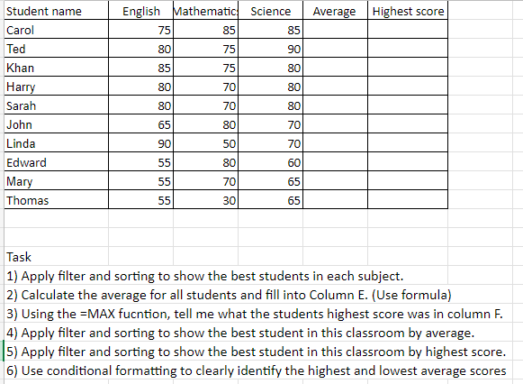

|  |  |
| --- | --- |
| Print screen 1 |  |

# Day 3: Task 1

Please download the dataset ‘Day_3_Task_1_Bike_Sales_Pivot_Lab.xlsx’ from [here](https://justit831-my.sharepoint.com/:x:/g/personal/danpe_justit_co_uk/Eb73L6LixCJHtafDJ4AOh-ABR9CVF0n9sdEgB4foSh261g?e=jh493A).

The lab instructions can be found [here](https://justit831-my.sharepoint.com/:b:/g/personal/danpe_justit_co_uk/EVySAtWQiEVDmrtCufrqTgwBuLVxX6mEKYqEAe0Mgl6b9Q?e=i05yOa). Do not worry if you do not complete the lab, just working with data and playing with the pivot table will be good experience.

Please paste your final pivot table below and complete the reflection questions:

|  |  |
| --- | --- |
| Print screen 1 |  |
| In which markets do Germany have customers? | Adults |
| What country has sales in all markets? | Australia |
| What are the most profitable markets by country, age group, and gender? | Australia is the most profitable country.  Adults are the most profitable age group.  Females are the most profitable gender. |
| Any other findings? | Note: This data has not been cleaned up. |

# Day 3: Task 2

The dataset below tracks the sales performance of different products in various counties in England. Please paste the dataset into a blank Excel workbook. Your task is to:

* **Create a Pivot Table** to summarise the data by county and product.
* **Use the SWITCH function** to categorise products based on their sales volume.

#### **Dataset:**

|  |  |  |
| --- | --- | --- |
| **County** | **Product** | **Sales Volume** |
| Yorkshire | Laptops | 500 |
| Yorkshire | Smartphones | 200 |
| Cornwall | Laptops | 700 |
| Cornwall | Printers | 400 |
| Lancashire | Smartphones | 150 |
| Lancashire | Laptops | 600 |
| Essex | Printers | 800 |
| Essex | Smartphones | 300 |
| Durham | Laptops | 250 |
| Durham | Printers | 300 |
| Greater Manchester | Smartphones | 600 |
| Greater Manchester | Laptops | 400 |

#### **Step 1: Create a Pivot Table**

* Select the dataset (columns A to C).
* Insert a Pivot Table to summarise the data by **County** in the rows and **Products** in the columns. Use **Sales Volume** as the value to be summarised.

#### **Step 2: Use the SWITCH Function**

In a new column next to your data, use the SWITCH function to categorise products based on **Sales Volume** as follows:

* + For sales greater than 600: **"High"**
  + For sales between 300 and 600: **"Medium"**
  + For sales less than 300: **"Low"**

**SWITCH Function Example**:

=SWITCH(TRUE, C2 > 600, "High", C2 >= 300, "Medium", "Low")

* Apply this formula to each row, and check if the products are categorised correctly.

#### **Submission:**

* A completed Pivot Table summarising sales by county and product.
* A new column in the dataset categorising products by sales volume using the SWITCH function.
  + Please paste your completed work below

|  |  |
| --- | --- |
| Print screen 1 |  |

# Day 3: Task 3

Please download the dataset ‘Day_3_Task_3_Bike_Sales_Visualisations_Lab.xlsx’ from [here](https://justit831-my.sharepoint.com/:x:/g/personal/danpe_justit_co_uk/ESeJLtyZhYxIpZXluVywvvkBxgx2EtpPUzmxLCzQBGTKNQ?e=naSu4B).

The lab instructions can be found [here.](https://justit831-my.sharepoint.com/:b:/g/personal/danpe_justit_co_uk/Ec1IWsNPl_ZMuaSbNcaLyVcByy3JcZaQgoG1FeFwO9neRQ?e=6lsJG1) Do not worry if you do not complete the lab, just working with data and playing with the charts will be good experience.

Please paste your results below:

|  |  |
| --- | --- |
| Print screen 1 |  |

|  |
| --- |
| **Course Notes** |

It is recommended to take notes from the course, use the space below to do so, or use the revision guide shared with the class:

|  |
| --- |
|  |

|  |
| --- |
| **Additional Information** |

We have included a range of additional links to further resources and information that you may find useful, these can be found within your revision guide.

**END OF WORKBOOK**

**Please check through your work thoroughly before submitting and update the table of contents if required.**

**Please send your completed work booklet to your trainer by submitting in MS Teams Assignment page.**